PRELAB!

Read the entire lab, and complete the prelab questions (Q1-Q2) on the answer sheet before coming to the laboratory.

1.0 Objectives
In the previous lab you learned how to program digital circuits on an FPGA using Quartus Prime and Questa ModelSim. You also learned how each circuit is related to a truth table and a logic expression. In this lab, you will design two circuits and, in the process, tackle one way of performing design entry: schematic capture. Other methods such as truth table and Verilog will be covered in future labs.

2.0 Setup
Create a folder on your U Drive as you did for Lab1 (e.g. U:\CPRE281\Lab02), and two sub-folders in this folder named \Lab02\lab2step1 and \Lab02\lab2step2. You will be saving your work and running your circuits in this lab from these two directories.

3.0 Circuit 1
You will derive the truth table, logic expression, and circuit diagram for the circuit described below.
NOTE: when a logic variable has a value of 1, we say that it is “asserted”.

Description:

You are to construct a logic circuit with and .
The logic is such that F is asserted only when A or B are asserted and C is not. First complete the truth table in the answer sheet, and then use it to construct a canonical sum-of-products (SOP) expression of the output F.

You are now ready to build the circuit. Quartus Prime has logic gates and other basic logic functions available under the name of primitives. This step in the lab, you will learn how to use logic gates to make your design in schematic capture mode.

You will need to create a new .qpf file and name it lab2step1. To do this select File -> New Project Wizard…
Click the Next > button then make the following settings:
Working directory: U:\Documents\CPRE281\Lab02\lab2step1
Name of project: lab2step1
Name of top level design: lab2step1
Then click the Next > button three times. On page [5 of 7], under the Device family choose Cyclone IV E. Under Available devices select the part number of the Cyclone IV FPGA that is on the DE2-115 board – EP4CE115F29C7. Then click the Next > button two more times and if your Summary looks correct click Finish.

Now, create a new .bdf file and add it to the project. To do this select File -> New. Under Design Files choose Block Diagram/Schematic File. Then select File -> Save As… Set the file name to lab2step1.bdf and ensure that the box for Add file to current project is checked before saving.

You should have a valid logic expression using AND, OR, and NOT gates. You will now start building the circuit, one logic gate at a time.

- Double click in an open space on the schematic to bring up the Symbol window.
- In the Libraries menu expand c:/intelfpga/20.1/quartus/libraries/ -> primitives -> logic. A list of gates will appear in the menu that you will need to create your project.
- Select the logic gate you want and hit the OK button. The gates are named by gate type and number of inputs to the gate, so a three-input AND gate is named and3 and so forth. Remember that your overall circuit has three inputs and one output.
- Don’t forget to label the input and output pins with their respective variable names just like you did in Lab01.
- Circuit elements can be moved around in the design by clicking and dragging them. When you have placed all gates where you want them, you can wire them together with the Orthogonal Node Tool.

Thus far, you have used the cursor as an arrow. This has allowed you to move around the design, and move circuit elements. Clicking on the Orthogonal Node Tool, the symbol of the upper tool bar will change the cursor’s function. The Orthogonal Node Tool is used to connect logic gates and other circuit elements together. You can also use this tool function by touching the cursor to the output or input of circuit element and dragging it to another element.

When you are done connecting your circuit, perform compilation as you did in Lab01. This prepares your design to be programmed into the FPGA to verify your digital circuit using hardware. You will also need to assign your inputs and outputs to the proper pins on the FPGA as you did in the previous lab. To make it easier for the TA to verify everyone’s design use the following input and output devices:

LOGICAL PIN NAME | HARDWARE DEVICE | FPGA PIN
A | SW2_DB | PIN_AB21
B | SW1_DB | PIN_AC21
C | SW0_DB | PIN_AD21
F | LEDG1_DB | PIN_AG25

Then you will need to compile again before programming the FPGA.
NOTE: If there is no file present to program to the FPGA, click the Add File… button. Open output_files and select the *.sof file.

When you are done with your design, have the lab instructor verify it, and mark his/her initials in your answer sheet. Close all lab2step1 files in Quartus Prime.

3.1 Compilation Error Troubleshooting
Error: ‘Instance “Inst” is already defined’
To differentiate between blocks in a BDF, Quartus gives each instance of a block a name. There is a known bug in Quartus where two blocks are sometimes automatically assigned the same name.

Solution:
Double click on the error in the console window (you may have to scroll up – see fig. 1). This should highlight the two blocks that have the same name. Next double click on one of the highlighted blocks to show the Symbol Properties window. See fig. 2. Change the name to something else and click OK.

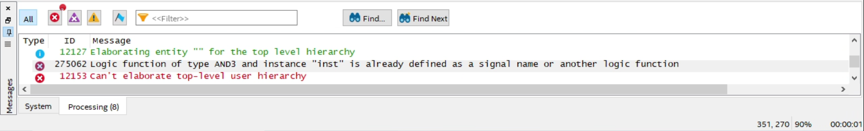
Fig. 1: Error in the Console Window

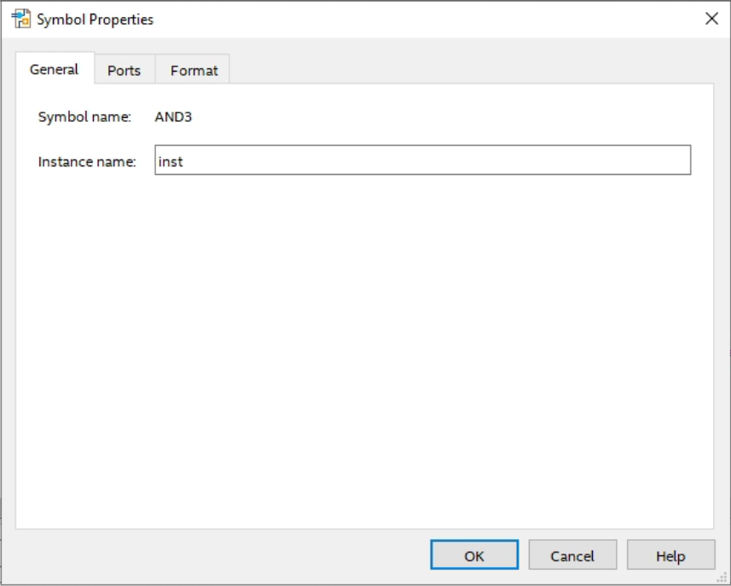
Fig. 2: Symbol Properties Window

Error: Net “gdfx_temp0” which fans out to “inst”, cannot be assigned more than one value.
This error can occur if you’ve accidentally connected two inputs to a gate together. An example of a faulty connection is shown below.
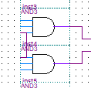 | 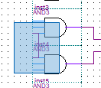 | 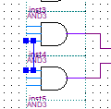
Fig. 3: Disconnecting gate inputs
Fig. 3a: Observe the connection | Fig. 3b: Select the connection | Fig. 3c: Delete the highlighted connection

In this case, the bottom input of AND gate “inst4” is connected to the top input of AND gate “inst5”.

4.0 Circuit 2
The problem used in this step will be revisited in future labs also to illustrate how designs can be created in different ways. In addition, we will also use Quartus to create a Verilog file for use in Questa. We will start by making the .bdf file in a new Quartus project as we did in lab2step1. Create a new .qpf file and name it lab2step2. Save this file under \CPRE281\Lab02\lab2step2. Also create a new .bdf file named lab2step2.bdf and add it to the project.

Description:
A farmer owns two barns; one north of a creek and the other south of the creek. The farmer has a Cabbage, a Goat, and a Wolf. The Farmer needs to put each item in a barn every night. If the Cabbage and Goat are in the same barn, the Goat will eat the Cabbage. If the Wolf and the Goat are in the same barn, the Wolf will eat the Goat. The Farmer is worried and you have to design an alarm circuit that will let him know if two items can safely be placed in a barn.

For this circuit, you have three and one.

If an input is in the north barn, it gets assigned a logic 1, and if it is in the south barn it gets assigned a logic 0. The output Alarm, asserts if there are two items in a barn that should not be kept together. Start by completing the truth table given in the answer sheet and use the truth table to construct a canonical sum-of-products (SOP) expression.

Follow the same steps described in the previous section for compiling your version of Lab2. When you are done connecting your circuit, you need to compile it as you did in Lab01. This prepares your design to be programmed into the FPGA, where you can verify your digital circuit in hardware. You will also need to assign your inputs and outputs to the proper pins on the FPGA as you did in the previous lab. To make it easier for the TA to verify your design, please use the following input and output devices:

LOGICAL PIN NAME | HARDWARE DEVICE | FPGA PIN
C | SW2_DB | PIN_AB21
G | SW1_DB | PIN_AC21
W | SW0_DB | PIN_AD21
F | LEDG1_DB | PIN_AG25

You will need to compile the circuit again before programming the FPGA. When you are done with your design, please make sure that your results are correct in FPGA board.
Note: This validation in the FPGA is essential to minimizing the iterative process of generating the Verilog file in Quartus Prime and validating it in Questa Sim.

Once you have finished making the BDF, you should next create the Verilog file for this BDF.
To create the Verilog File from the BDF:
- Select File Create/Update Create HDL Design from Current File
- In the new window, ensure that “Verilog HDL” is selected and press OK.
- After a second, the Verilog file will be created. You should be able to find this file in the same folder as the BDF.
Now, open and simulate the newly created Verilog File in Questa ModelSim
- Name the project lab2step2 and remember to Add lab2step2.v to your project afterwards.
- Compile the Verilog and Start Simulation
- Select all of the input and output objects, then press Ctrl-W to generate waveforms.
- Force the inputs to 0 (1’h0) or 1 (1’h1), then type the run 100 command to observe the output. Be sure to include all input combinations.

When you are done with your design, have the lab instructor verify it, and mark his/her initials in your answer sheet. Close all lab2step2 files in Quartus Prime and Questa.

5.0 Complete
You are done with this lab. Ensure that all lab files are closed, exit Quartus Prime, log off the computer, power down the DE2-115 board, and hand in your answer sheet. Don’t forget to write down your name, student ID, and your lab section number.

